**Unit Testing of SHAW OM PointOfSales From Cloud to LogFire**

**Process to create test data**

**Query to get the Serial numbers which are in issued out of stores status of a particular org in ERP:**

SELECT

iop.organization_code,

sib.item_number,

isn.current_subinventory_code,

fl.meaning serial_status,

isn.serial_number,

isn.lpn_id,

isn.last_update_date,

isn.last_updated_by,

isn.creation_date,

isn.created_by

FROM

inv_serial_numbers isn,

inv_org_parameters iop,

egp_system_items_b sib,

fnd_lookups fl

WHERE

fl.lookup_type = 'INV_SERIAL_NUM_STATUS'

AND isn.current_status = fl.lookup_code

AND isn.current_organization_id = iop.organization_id

AND isn.current_organization_id = sib.organization_id

AND isn.inventory_item_id = sib.inventory_item_id

AND isn.last_update_date =

(

SELECT

Max(last_update_date)

FROM

inv_serial_numbers

WHERE

serial_number = isn.serial_number

)

AND iop.organization_code = 'CGY'

AND fl.meaning LIKE 'Issued out%'

ORDER BY

isn.serial_number;

* Select some transactions from the above query and receive it manually through ERP application

**Step 2:** To receive the serials in ERP follow the Navigation

* **Supply Chain Execution>Inventory Management>Create Miscellaneous Transaction**

**Enter Organization**

**Transaction_Type**: Shaw Project Receipt

**Account**: 200.0000.15010.051999.0000.00000.000000.000

* Enter Item Number, Sub inventory, Quantity
* Click the Records lots and serial numbers tab and enter the serial numbers in **enter single serial number** tab

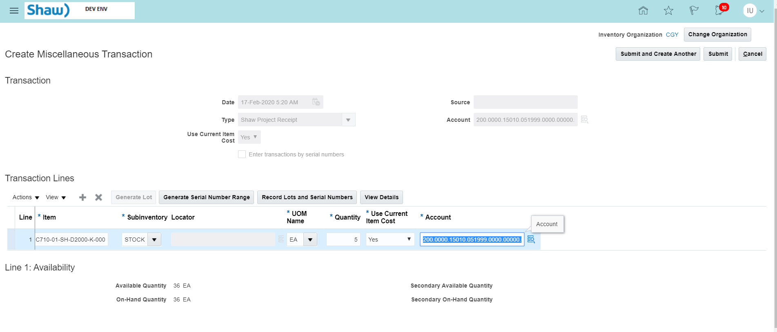

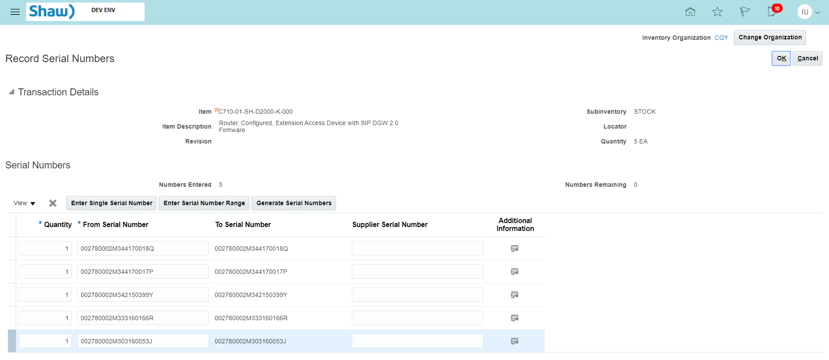



Click Ok button

Click View Details





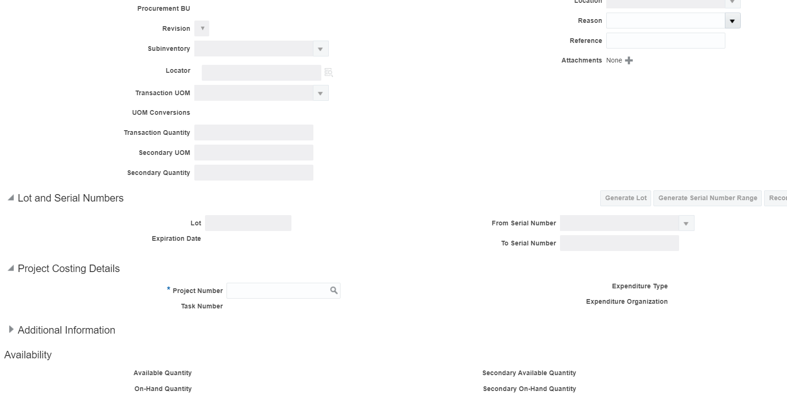

To get the **Active Project Number and Task Number** run the below query in cloud ERP

select

'''' || a.segment1 || '|' || b.task_number || ''',',

a.project_status_code,

a.segment1,

b.task_number,

b.CHARGEABLE_FLAG,

case

when

b.completion_date > sysdate

then

'Active'

else

'Inactive'

end

Task_Status

from

pjf_projects_all_vl a, pjf_tasks_v b

where

a.project_id = b.project_id

and a.project_status_code = 'ACTIVE'

and b.CHARGEABLE_FLAG = 'Y'

and b.completion_date > sysdate;

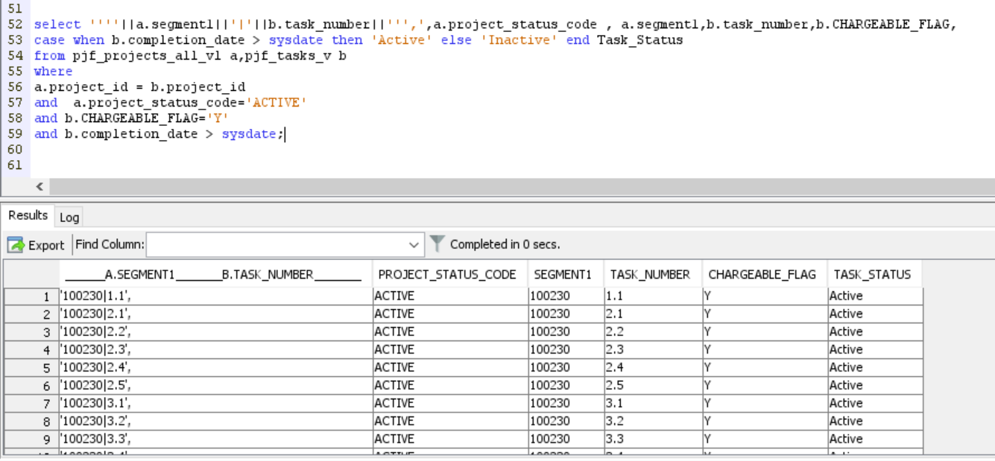

**Enter Active Project Number ,Task Number ,Expenditure Organization : Accounting**

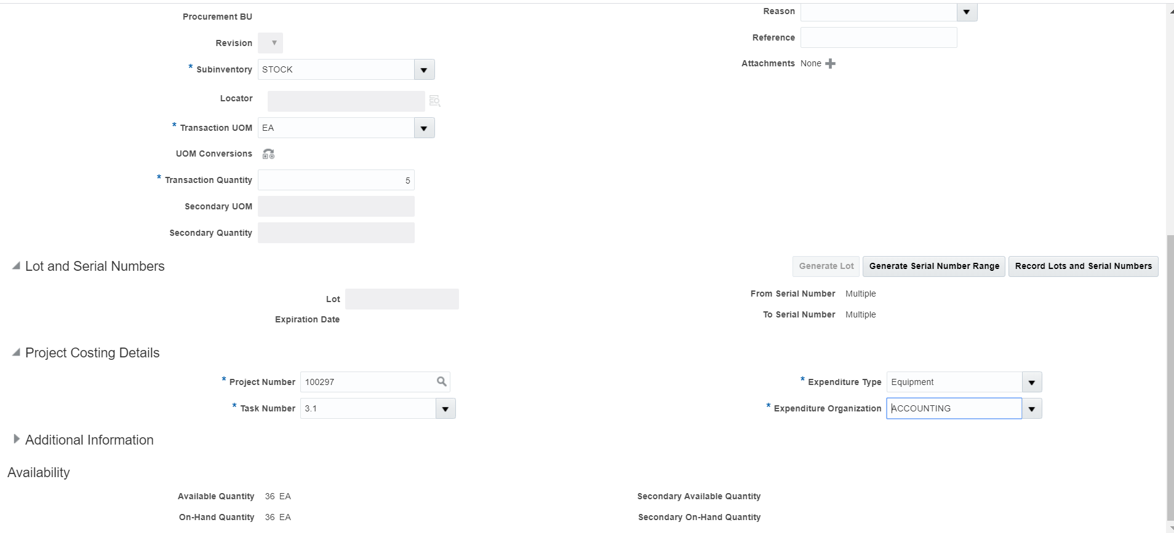

**CLICK OK BUTTON**

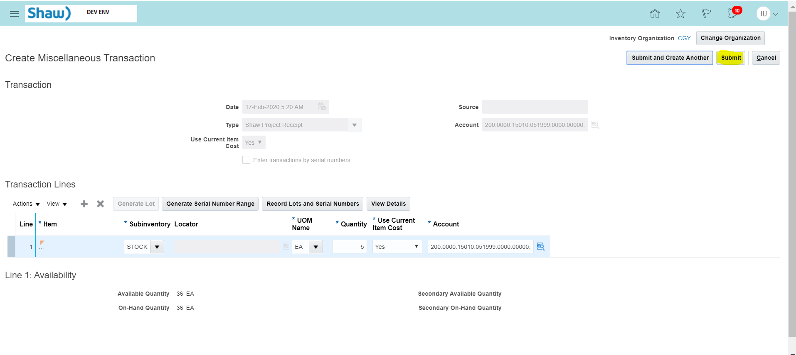

**Click Submit button.**

**After creating test data using above process, Check the Status of serial numbers in ERP.**

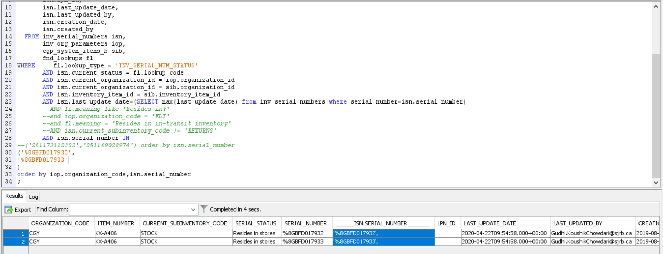

Now , the serial numbers are received in ERP

**Latest POS logic change for deriving location - based on JIRA ticket - OC-1549**

**Run the below query to check whether test data is valid or not**

SELECT

org.organization_code facility_code,

'SHAW' company_code,

CASE

WHEN typ.transaction_type_name IN (

'Shaw WIP Component Issue',

'Shaw Inv Adj Issue',

'Shaw Project Issue',

'Whse to Float'

) THEN

'SALE'

ELSE

'RETURN'

END tranasction_type,

inv.transaction_id,

ROW_NUMBER() OVER(

PARTITION BY inv.transaction_id

ORDER BY

inv.transaction_id

) seq_nbr,

'' ref_transaction_id,

'' ref_seq_nbr,

CASE

WHEN typ.transaction_type_name = 'Shaw WIP Component Issue' THEN

'WKITTING001'

WHEN typ.transaction_type_name = 'Float to Whse' THEN

'RT002'

WHEN typ.transaction_type_name IN (

'Shaw Inv Adj Issue',

'Shaw Project Issue'

) THEN

inv.attribute1

WHEN typ.transaction_type_name IN (

'Shaw Project Receipt'

) THEN

'REC002'

WHEN typ.transaction_type_name ='Whse to Float' THEN

NULL

WHEN typ.transaction_type_name = 'Transfer Order Interorganization Transfer' THEN

'S002'

END location,

(

SELECT

itm.item_number

FROM

egp_system_items_b itm

WHERE

itm.inventory_item_id = inv.inventory_item_id

AND itm.organization_id = inv.organization_id

) ITEM_ALTERNATE_CODE,

inv.aging_expiration_date expiry_date,

txn.serial_number,

CASE

WHEN serial_number IS NULL THEN

abs(inv.primary_quantity)

ELSE

1

END primary_quantity

FROM

inv_material_txns inv,

inv_unit_transactions txn,

inv_org_parameters org,

inv_transaction_types_vl typ

WHERE

inv.transaction_id = txn.transaction_id (+)

AND inv.organization_id = org.organization_id

AND inv.transaction_type_id = typ.transaction_type_id

AND typ.transaction_type_name IN (

'Shaw WIP Component Issue',

'Shaw Inv Adj Issue',

'Shaw Project Issue',

'Whse to Float',

'Float to Whse',

'Transfer Order Interorganization Transfer',

'Shaw Project Receipt'

)

AND ( ( typ.transaction_type_name IN (

'Shaw Inv Adj Issue',

'Shaw Project Issue'

)

AND inv.attribute1 IS NOT NULL )

OR ( typ.transaction_type_name NOT IN (

'Shaw Inv Adj Issue',

'Shaw Project Issue'

) ) )

AND ( ( typ.transaction_type_name = 'Transfer Order Interorganization Transfer'

AND org.attribute4 = 'MINOR' ) OR ( typ.transaction_type_name != 'Transfer Order Interorganization Transfer' ) )

AND org.organization_code NOT IN (

'FLD',

'FLT',

'DC1'

)

AND

(

inv.creation_date > to_timestamp('2020-02-11 23:03:10.647000000', 'YYYY-MM-DD HH24:MI:SS.FF')

AND inv.creation_date <= to_timestamp('2020-02-12 19:05:30.647000000', 'YYYY-MM-DD HH24:MI:SS.FF')

)

;

**Change timestamp according in the above query.**

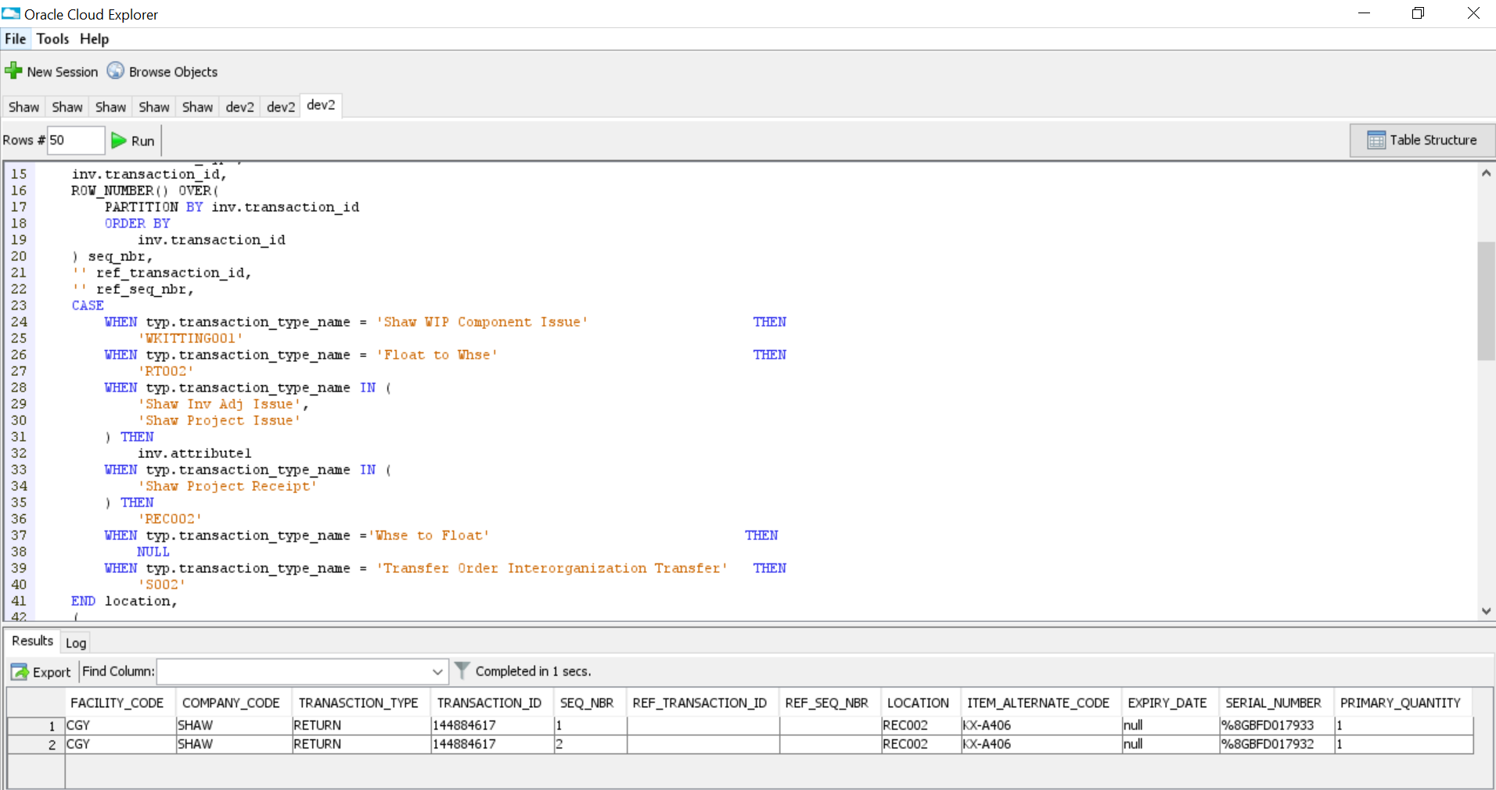

Test Data is valid.

Run the integration “SHAW OM PointOfSales From Cloud to LogFire”

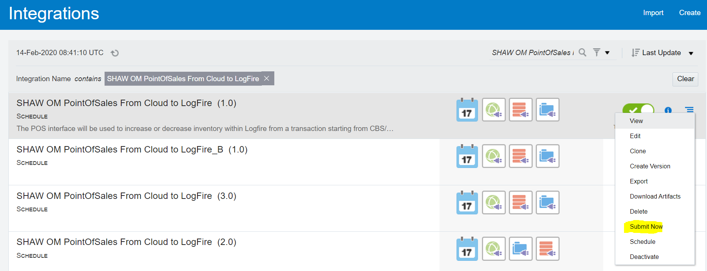

Run the below query to get Current_Run_Date and Last_Successful_Run

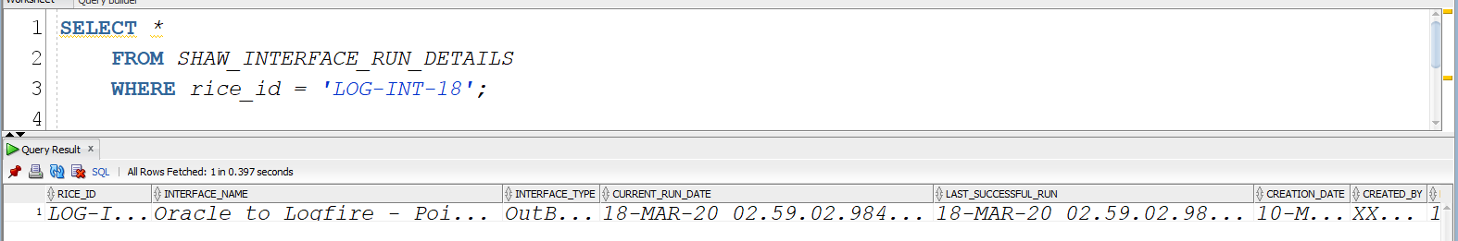

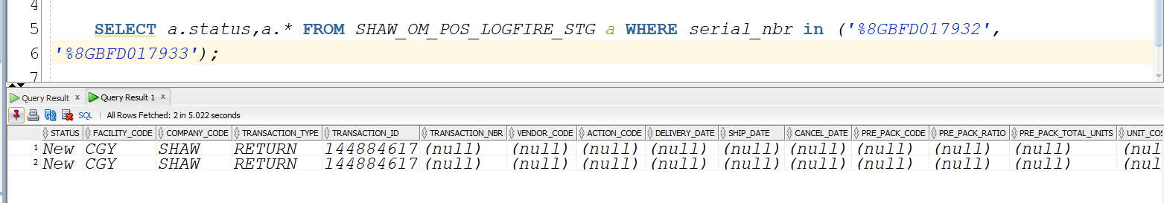

The records got inserted in SHAW_OM_POS_LOGFIRE_STG

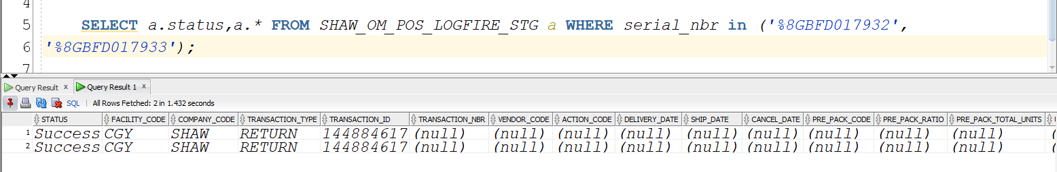

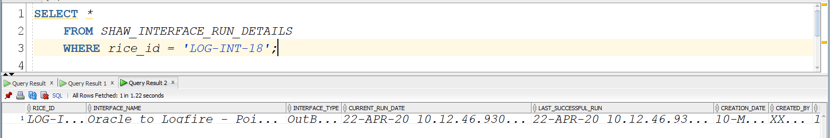

Current_Run_Date and Last_Successful_Run has been updated.

Tracking in ICS

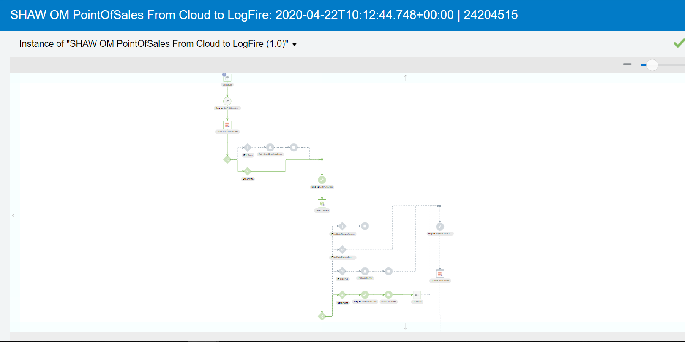

File is created in Out and Archive folder in FTP Server

